**FLORDIA ATLANTIC UNIVERSITY**

**EMBEDDED SYSTEMS DESIGN**

**CDA 4630**

**PROPOSAL FOR SMART THERMOSTAT**

**SPRING 2024**

**PROF. ALHALABI**

**DUE: 2/28/2024**

**BY: LUIS RODRIGUEZ-BAZ, MICHAEL BRYAN**

**Introduction:**

The smart thermostat offers unparalleled benefits in modern homes. Leveraging advanced features and connectivity options, these devices can help optimize energy usage, enhance convenience, and integrate sensors to co-exist in home settings. The usage of light, motion, and temperature sensors leads to the adjustment of the thermostat. Along with the sensors, a keypad and screen will be used to manually adjust temperatures and even lock it from usage if needed.

**Parts:**

* 1 Motion Sensor
* 3 Temp Sensors
* 2 Light Sensors
* DC Motor
* 2 Servo Motor
* 3 LED’s
* Keypad
* Screen

**General Block Diagram:**

Our General block diagram of the smart thermostat includes:

* **Sensors:** 1 motion sensor, 3 temperature sensors, 2 light sensors to gather data on the necessary surrounding environmental conditions
* **Motors:** 1 DC Motor, 2 Servo Motors. DC motor will be used to simulate fan with variable speed. Servo motor will simulate partial opening of vents.
* **LEDs:**  3 LEDs will be used to simulate the AC and the heat elements
* **Keypad:** Keypad will be used to adjust temperatures (user settings) and set potential passwords if main user wants to lock it.
* **Screen:** The screen will be used to display the status of Thermostat (Temperature)

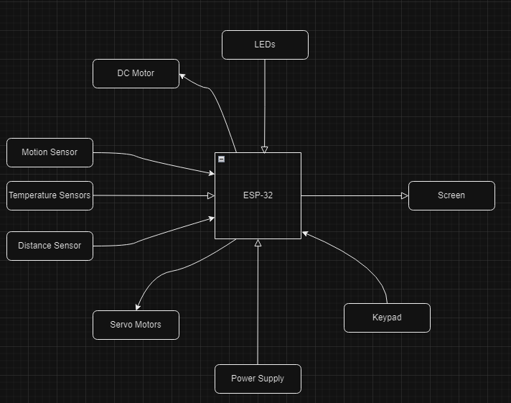

With the parts mentioned earlier, we will route many of them to the ESP-32 and have the board draw power while also projecting to a screen.

**Components/Usage/Concept**

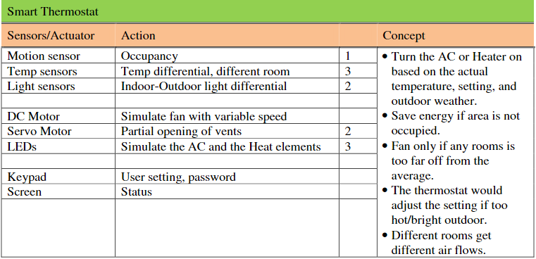

**Project Flow**

1. Check for occupancy with motion motors

2. Time it to check every half hour. Toggle feature for motion. (motion Sensor)

3. Check avg temperature of all rooms (Motion/temp sensor in each room)

4. Program vents for specific room sizes

5. Use light sensor to check if too bright/hot outside. Thermostat adjusts

6. Keypad and screen used to manually adjust temperatures and lock it from others usage.

7. Screen used for status cycling and updates.